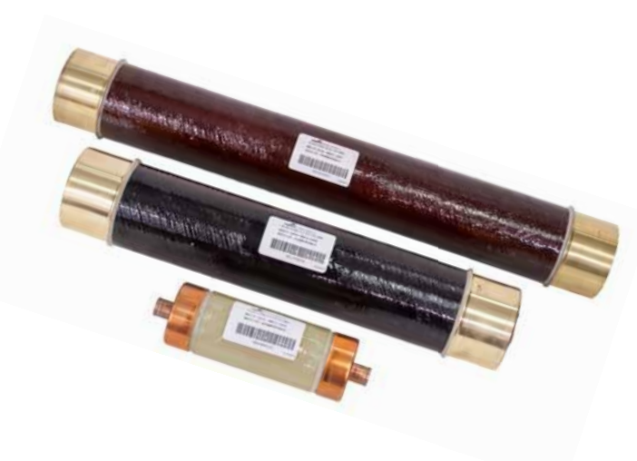

The Role of ELSP Current-Limiting Backup Fuse in Transformers
In transformers, the ELSP current-limiting backup fuse is a crucial safety device designed to protect the transformer and associated equipment from severe short circuits and overloads. It serves as an efficient backup protection, kicking in when primary protection systems fail or when fault currents reach critical levels, ensuring the system’s safe operation.

Key Functions of the ELSP Fuse in Transformers
- Current Limiting: The ELSP fuse is engineered to quickly limit the fault current flowing through the transformer during short circuits or overload conditions. By rapidly cutting off excessive current, it minimizes the risk of mechanical and thermal damage to the transformer’s windings, insulation, and other key components.
- Backup Protection: ELSP fuses work in coordination with other protection devices, such as circuit breakers or primary fuses, to provide an additional layer of safety. When the primary protection fails to respond promptly or the fault current exceeds the capabilities of other devices, the ELSP fuse steps in as the last line of defense, swiftly disconnecting the faulty circuit to prevent equipment damage or system failure.
- Preventing Catastrophic Failures: Faults like short circuits and overloads can cause dangerous conditions, such as overheating, arcing, or even transformer explosions. The ELSP fuse mitigates these risks by quickly interrupting fault currents, preventing dangerous conditions that could lead to fires or catastrophic system failures.
- Enhancing Grid Stability: Transformers play a key role in power distribution and transmission, and sudden failures can destabilize the grid. The fast-acting nature of the ELSP fuse helps isolate problems quickly, preventing fault propagation to other parts of the grid and ensuring overall system stability and continuity of service.
- Extending Equipment Lifespan: Transformers are exposed to various electrical stresses, including fluctuating loads and external grid disturbances. The ELSP fuse provides an extra layer of protection, shielding the transformer from excessive electrical and thermal stress, which in turn prolongs the lifespan of the equipment and reduces maintenance or replacement costs.
- Ease of Maintenance: ELSP fuses are compact, easy to install, and straightforward to replace. They require minimal ongoing maintenance, offering a highly reliable protection solution in transformer applications across various power systems.

How It Works
The ELSP current-limiting fuse operates by using specially designed materials that react rapidly to overcurrent conditions. When a fault occurs, the fuse melts and forms an arc, which is extinguished by the fuse’s internal structure. This process interrupts the flow of fault current within milliseconds, effectively protecting the transformer and isolating the fault.

Conclusion
The ELSP current-limiting backup fuse is an essential component in modern transformer protection schemes. It not only safeguards the transformer from severe electrical faults but also contributes to greater reliability and safety in the power grid. Its ability to act swiftly in high-energy fault situations ensures the longevity of transformers and enhances overall system stability.
#TransformerProtection #CurrentLimitingFuse #ELSP #ElectricalSafety #PowerSystems #GridStability #EquipmentLifespan #ElectricalProtection

**ELSP限流后备熔断器在变压器中的作用**
在变压器中，ELSP限流后备熔断器是一种关键的安全装置，旨在保护变压器及相关设备免受严重短路和过载的损害。它作为一种高效的后备保护，在主保护系统失效或故障电流达到临界水平时启动，确保系统的安全运行。

**ELSP熔断器在变压器中的关键功能**
1. **限流功能**：ELSP熔断器设计用于在短路或过载条件下快速限制流经变压器的故障电流。通过迅速切断过大的电流，它最大限度地减少变压器绕组、绝缘和其他关键部件受到机械和热损伤的风险。
2. **后备保护**：ELSP熔断器与其他保护设备（如断路器或主熔断器）协同工作，提供额外的安全层。当主保护未能及时响应或故障电流超出其他设备的能力范围时，ELSP熔断器作为最后一道防线介入，迅速断开故障电路，防止设备损坏或系统故障。
3. **防止灾难性故障**：短路和过载等故障可能导致过热、电弧甚至变压器爆炸等危险情况。ELSP熔断器通过快速切断故障电流来降低这些风险，防止可能引发火灾或灾难性系统故障的危险情况。
4. **增强电网稳定性**：变压器在配电和输电中起着关键作用，突发故障可能导致电网不稳定。ELSP熔断器的快速动作特性有助于迅速隔离问题，防止故障蔓延到电网的其他部分，从而确保系统的整体稳定性和服务的连续性。
5. **延长设备寿命**：变压器面临各种电气应力，包括负载波动和外部电网干扰。ELSP熔断器提供额外的保护层，使变压器免受过度的电气和热应力影响，从而延长设备寿命并降低维护或更换成本。
6. **便于维护**：ELSP熔断器结构紧凑、易于安装和更换。它们几乎不需要持续维护，为各种电力系统中的变压器应用提供了高度可靠的保护解决方案。

**工作原理**
ELSP限流熔断器通过使用特殊设计的材料来快速响应过流情况。当发生故障时，熔断器熔断并形成电弧，随后被熔断器的内部结构熄灭。这一过程在几毫秒内中断故障电流，有效保护变压器并隔离故障。

**结论**
ELSP限流后备熔断器是现代变压器保护方案中的重要组成部分。它不仅保护变压器免受严重电气故障的损害，还为电网的可靠性和安全性做出了贡献。它在高能量故障情况下的快速动作能力确保了变压器的长寿命，并增强了系统的整体稳定性。

#变压器保护 #限流熔断器 #ELSP #电气安全 #电力系统 #电网稳定性 #设备寿命 #电气保护

